Step 0: timing constraints changes in PF-CCSL （snap from XText）



# step 1: problem description of Interlocking System

1. When the train enters the track, it sends a request signal to the control center and waits for the traffic light signal.
2. After receiving the query result signal "result", the control center sends the detecting occupancy signal "checkoccupied" to the track to detect the occupation of the track.
3. After receiving the detecting occupancy signal, the track check whether the track is occupied. If the track is occupied, it sends the occupied signal "occupied" to the control center. If not occupied, it sends the unoccupied signal "unoccupied". When the train receiving the signal "trainEnter", the track is set to be occupied, and the track condition is not occupied when the train sends the train departure signal "trainLeave".
4. If the track is unoccupied, the control center sends the green pulse signal to the signal light. If the track is occupied, the control center sends the red pulse signal to the signal light.
5. The initial state of the signal Light is red light. After receiving the green pulse, it becomes a green light state. After receiving the red pulse, it becomes a red light state.
6. If the train sees the red light, it will wait. If the train sees the green light, it will enter, and finally leaves the station.
7. After the train sends the request, the train will wait or enter will be in 50 ms.
8. The response time of the light is 30 ms.
9. From checking the state of track to the set light, the time bound in 40 ms.

# step 2: Timing requirements and physical world description of Interlocking system in PF-CCSL

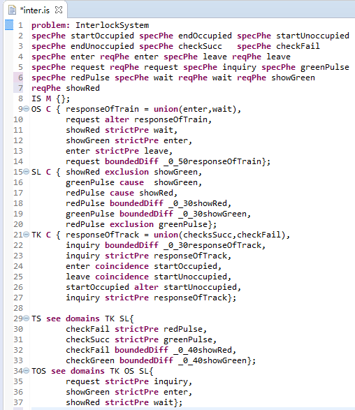

# Step 3: change

Signal light changes:

The constraints in line 18, 19 changes to:

redPulse boundedDiff_0_20 showRed,

greenPulse boundedDiff_0_20 showGreen,

# step 4: model checking of satisfaction property

1. The model checking file .smv

MODULE main

VAR

startOccupied:boolean;

endOccupied:boolean;

startUnoccupied:boolean;

endUnoccupied:boolean;

checkSucc:boolean;

checkFail:boolean;

responseOfTrack:boolean;

enter:boolean;

leave:boolean;

request:boolean;

inquiry:boolean;

greenPulse:boolean;

redPulse:boolean;

wait:boolean;

startUnion:boolean;

responseOfTrain:boolean;

showGreen:boolean;

showRed:boolean;

ctr1:unionn(checkSucc,checkFail,responseOfTrack);

ctr2:boundeddiff(inquiry,responseOfTrack,0,30);

ctr3:strictpre(inquiry,responseOfTrack,5);

ctr4: coincidence(enter,startOccupied);

ctr5: coincidence(leave,startUnoccupied);

ctr6: Alter(startOccupied,startUnoccupied);

ctr7:unionn(enter,wait,responseOfTrain);

ctr8:Alter(request,responseOfTrain);

ctr9:strictpre(showRed,wait,5);

ctr10:strictpre(showGreen,enter,5);

ctr11:strictpre(enter,leave,5);

ctr12:boundeddiff(request,responseOfTrain,0,50);

ctr13:exclusion(showRed,showGreen);

ctr14:cause(greenPulse,showGreen,5);

ctr15:cause(redPulse,showRed,5);

ctr16:boundeddiff(redPulse,showRed,0,30);

ctr17:boundeddiff(greenPulse,showGreen,0,30);

ctr18:strictpre(checkFail,redPulse,5);

ctr19:strictpre(checkSucc,greenPulse,5);

ctr20:boundeddiff(checkFail,showRed,0,40);

ctr21:boundeddiff(checkSucc,showGreen,0,40);

ctr22:strictpre(request,inquiry,5);

ctr23:strictpre(showGreen,enter,5);

ctr24:strictpre(showRed,wait,5);

ctr25:strictpre(inquiry,responseOfTrack,5);

ctr26:exclusion(redPulse,greenPulse);

ASSIGN

init(startOccupied):=FALSE;

init(endOccupied):=FALSE;

init(startUnoccupied):=FALSE;

init(endUnoccupied):=FALSE;

init(checkSucc):=FALSE;

init(checkFail):=FALSE;

init(enter):=FALSE;

init(leave):=FALSE;

init(request):=FALSE;

init(inquiry):=FALSE;

init(greenPulse):=FALSE;

init(redPulse):=FALSE;

init(wait):=FALSE;

init(responseOfTrain):=FALSE;

init(startUnion):=FALSE;

init(responseOfTrack):=FALSE;

init(showRed):=TRUE;

init(showGreen):=FALSE;

CTLSPEC (! EF AG !(startOccupied|endOccupied|startUnoccupied|endUnoccupied|checkSucc|checkFail|enter|leave|request|inquiry|greenPulse|redPulse|wait|startUnion|responseOfTrack))

MODULE strictpre(left,right,n)

VAR

coun:0..n;

INIT

coun=0;

TRANS

case

coun=0: (next(left)=TRUE & next(right)=FALSE & next(coun)=coun+1)|(next(left)=FALSE & next(right)=FALSE & next(coun)=coun);

coun<n: (next(left)=TRUE & next(right)=FALSE & next(coun)=coun+1)|(next(left)=TRUE & next(right)=TRUE & next(coun)=coun)|(next(left)=FALSE & next(right)=TRUE & next(coun)=coun - 1)|(next(left)=FALSE & next(right)=FALSE & next(coun)=coun);

TRUE: (next(left)=TRUE & next(right)=TRUE & next(coun)=coun)|(next(left)=FALSE & next(right)=TRUE & next(coun)=coun - 1)|(next(left)=FALSE & next(right)=FALSE & next(coun)=coun);

esac

MODULE unionn(left,right,new)

TRANS

(next(left)=TRUE & next(new)=TRUE)|(next(right)=TRUE & next(new)=TRUE)|(next(left)=FALSE & next(right)=FALSE & next(new)=FALSE)

MODULE boundeddiff(left,right,i,j)

VAR

dif: i..j;

INIT

dif=0

TRANS

case

dif=j:((next(left)=FALSE&next(right)=TRUE&next(dif)=dif - 1) | (next(left)=TRUE&next(right)=TRUE&next(dif)=dif) | (next(left)=FALSE&next(right)=FALSE&next(dif)=dif));

dif=i:((next(left)=TRUE&next(right)=FALSE&next(dif)=dif+1) | (next(left)=TRUE&next(right)=TRUE&next(dif)=dif) | (next(left)=FALSE&next(right)=FALSE&next(dif)=dif));

TRUE:(next(left)=TRUE&next(right)=FALSE&next(dif)=dif+1) | (next(left)=FALSE&next(right)=TRUE&next(dif)=dif - 1) | (next(left)=TRUE&next(right)=TRUE&next(dif)=dif) | (next(left)=FALSE&next(right)=FALSE&next(dif)=dif);

esac

MODULE cause(left,right,n)

VAR

scnt:0..n;

INIT

scnt=0

TRANS

case

scnt=0:((next(left)=TRUE&next(right)=FALSE&next(scnt)=scnt+1) | (next(left)=FALSE&next(right)=FALSE&next(scnt)=scnt) | (next(left)=TRUE&next(right)=TRUE&next(scnt)=scnt));

scnt>0&scnt<n:(next(left)=TRUE&next(right)=FALSE&next(scnt)=scnt+1) | (next(left)=TRUE&next(right)=TRUE&next(scnt)=scnt) | (next(left)=FALSE&next(right)=TRUE&next(scnt)=scnt - 1) | (next(left)=FALSE&next(right)=FALSE&

next(scnt)=scnt);

scnt=n:(next(left)=TRUE&next(right)=TRUE&next(scnt)=scnt) | (next(left)=FALSE&next(right)=TRUE&next(scnt)=scnt - 1) | (next(left)=FALSE&next(right)=FALSE&next(scnt)=scnt);

esac

MODULE coincidence(left,right)

TRANS

next(left)->next(right)&next(right)->next(left)

MODULE subclock(left,right)

TRANS

next(left)->next(right)

MODULE delay(left,right,k)

VAR

cnt:0..k;

INIT

cnt=0;

TRANS

case

cnt<k: next(left)=FALSE & ((next(right)=TRUE & next(cnt)=cnt+1)|(next(right)=FALSE & next(cnt)=cnt));

cnt=k|cnt>k: (next(left)=TRUE & next(right)=TRUE & next(cnt)=cnt)|(next(left)=FALSE & next(right)=FALSE & next(cnt)=cnt);

esac

MODULE exclusion (left, right)

TRANS

(next (left)=TRUE & next (right)=FALSE) | (next(left)=FALSE & next (right)=TRUE)| (next(left)=FALSE & next (right)=FALSE);

MODULE Alter(left,right)

VAR

state:boolean;

INIT

state=FALSE;

TRANS

case

state = FALSE : (next(right)=FALSE & next(left)=TRUE & next(state) = TRUE )|(next(right)=FALSE & next(left)=FALSE & next(state)=FALSE);

state = TRUE : (next(left)=FALSE & next(right)=TRUE & next(state) = FALSE)|(next(left)=FALSE & next(right)=FALSE & next(state)=TRUE);

esac

1. verification result

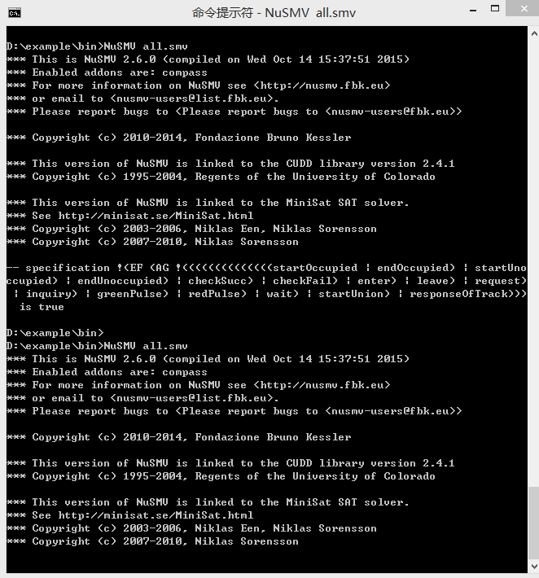

# step 5: Specification derivation

